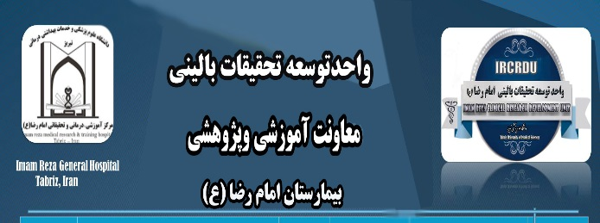 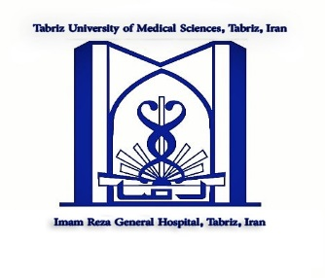

**Acknowledgment:**

We would like to appreciate of the cooperation of Clinical Research Development Unit, Imam Reza General Hospital, Tabriz, Iran in conducting of this research.